Press Release:
Adult Citizens Police Academy 2020
Contact Person:
Jacqueline Marrero
717.849.2216

The Adult Citizen Police Academy is an outreach program sponsored by the York City Police Department. This program meets twice a week for four weeks. It’s designed to give participants an inside look at police operations and how the department interacts with the community. The sessions will cover a variety of topics that pertain to law enforcement and the variety of duties that entails.

The Academy is scheduled to start Tuesday, March 17th, 2020, and will continue through Thursday, April 9th, 2020. Classes are held on Tuesdays and Thursdays evenings, 6 - 8:30pm. A total of 8 sessions. Space is limited to forty applicants so please register early. All interested are encouraged to apply.

Application link: https://www.yorkcity.org/city-services/departments/police-department/citizens-police-academy-form/
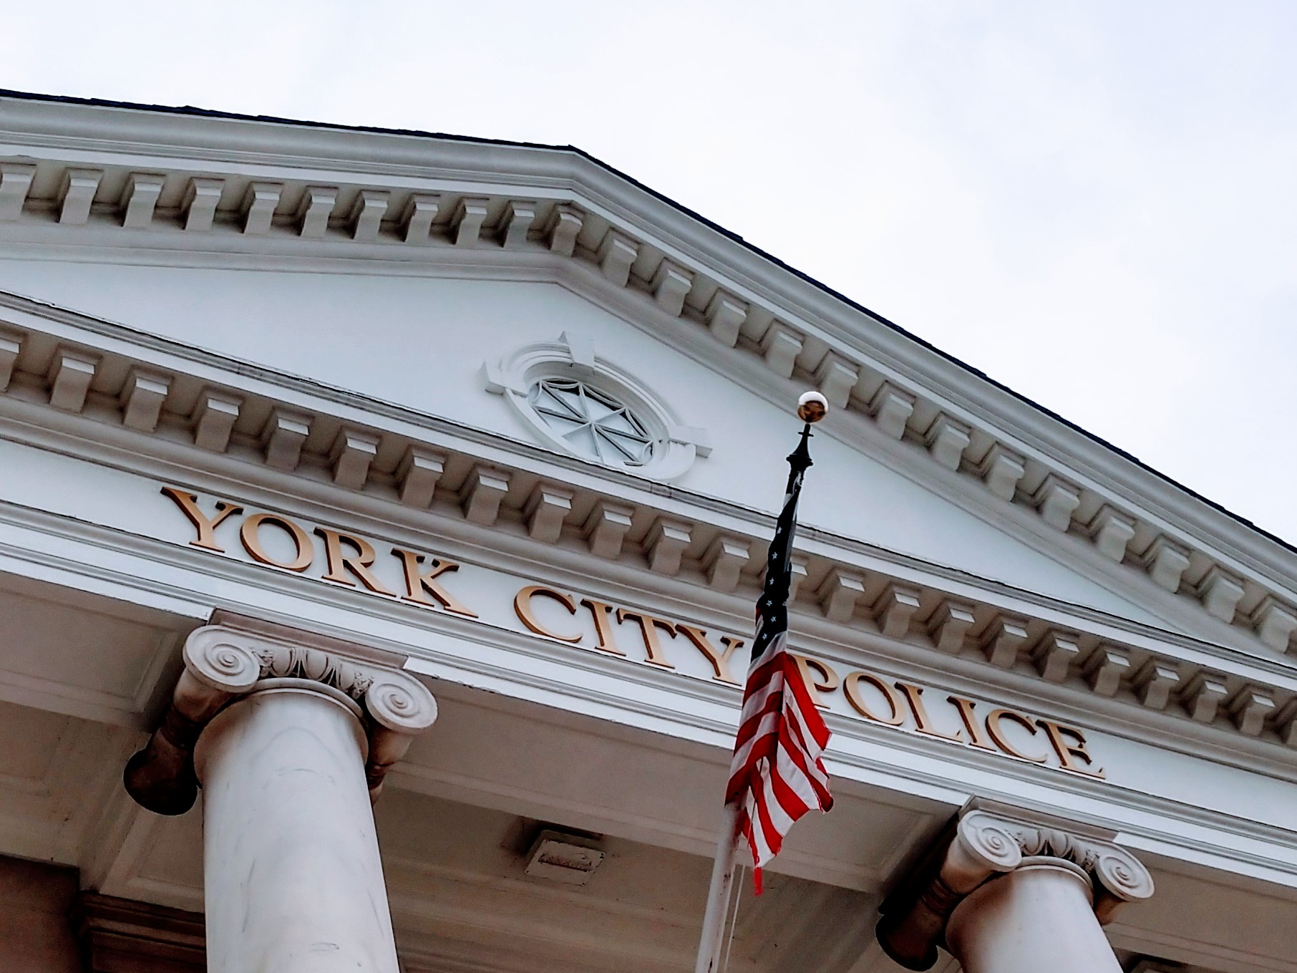

*Quarter Master/Evidence
*Patrol
*Firearms Training Simulator
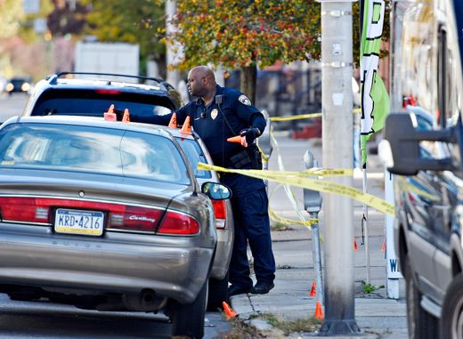
(FATS)
*The Narcotics Unit
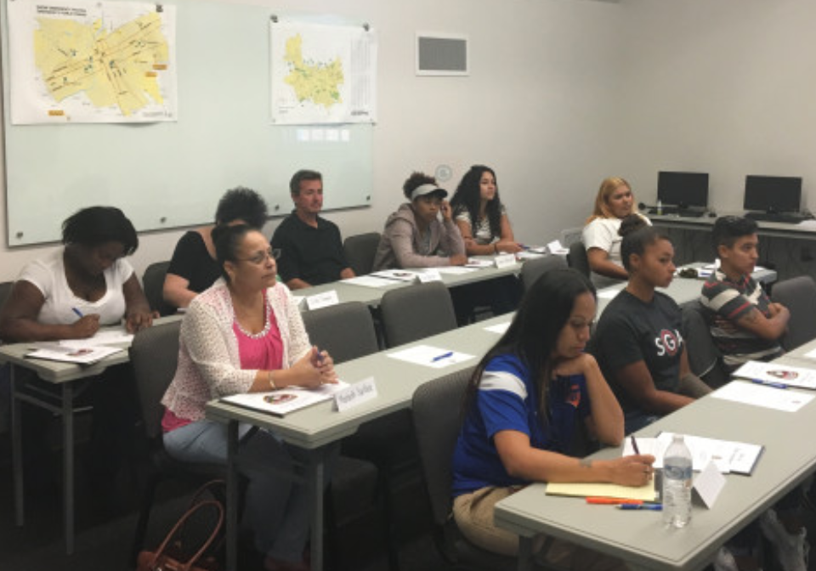
*Central Booking
*Police Dept. Station
*QRT/NRT
*Detective Bureau
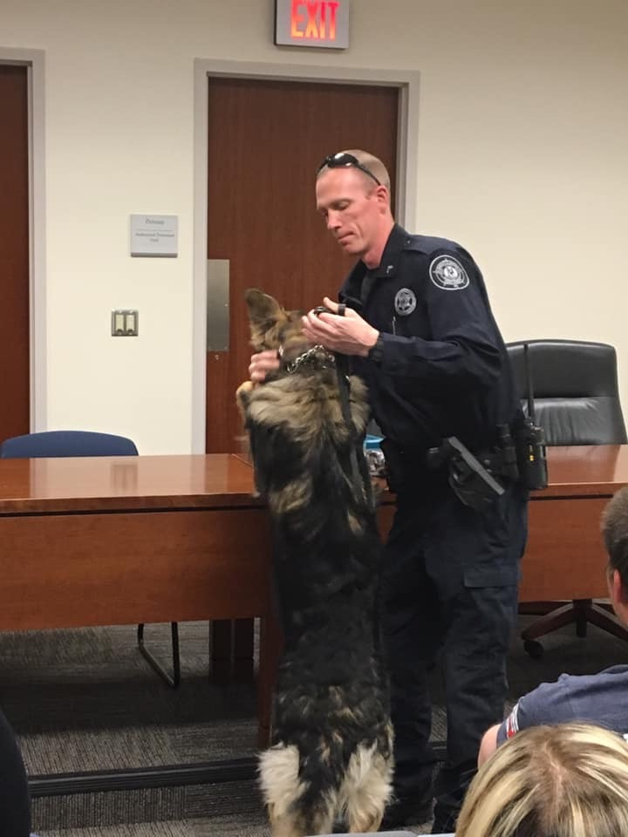
*Animal Control Officer
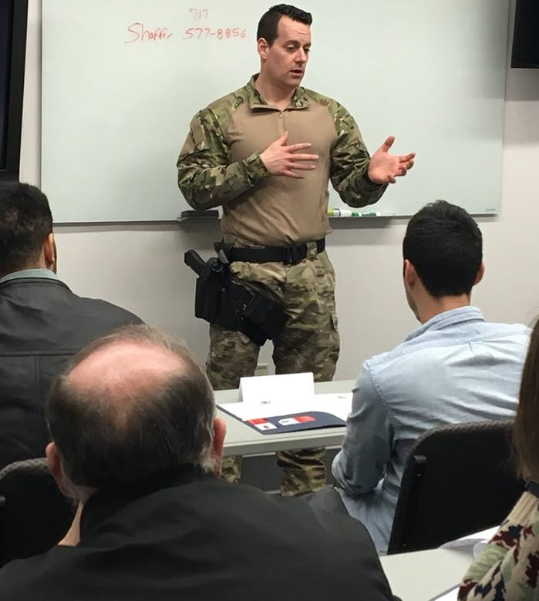
*York County Sheriffs Dept. K-9 Unit
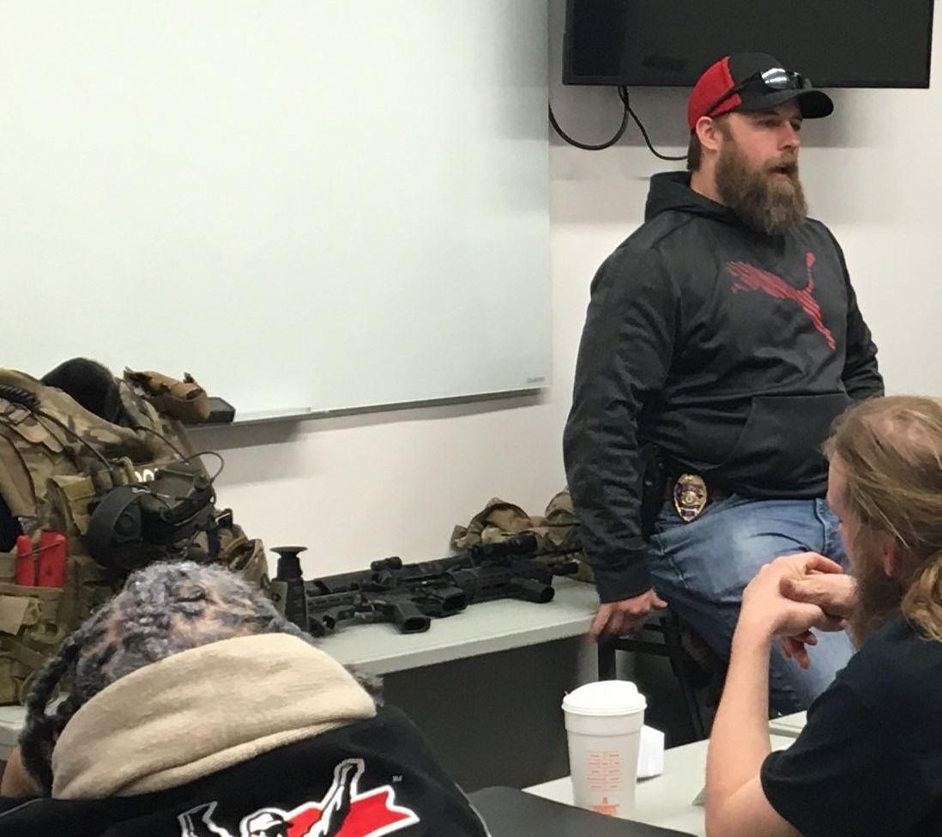
*911 Center Tour
*District Attorney’s Office
*Public Defenders Office

Must register by Friday, March 6th, 2020.
CITIZEN POLICE ACADEMY APPLICATION FORM
(For citizens residing or working in the City of York)

Name (First, middle, last) ___________________________________________________
Address: _________________________________________________________________
City ________________________ State ______________ Zip Code __________________
Home phone _________________ Work or Cell# _________________________________
Email Address_____________________________________________________________

Driver’s License # _____________ State: _______ Occupation: ______________________
Birth Date: ________________ Height______ Eye Color________ Hair Color___________

Employer: _________________________________________________________________
Work Address ______________________________________________________________
Supervisor’s Phone # ________________________________________________________

Have you ever been arrested? _____ Yes _____ No
*If yes, please explain including when and where the incident occurred:

What past personal experience have you had involving a law enforcement officer?
Positive _________ Negative___________

Please briefly explain:

Why are you interested in attending the Citizen Police Academy? Briefly explain:

What do you expect to gain from this program?

Emergency Contact: ________________________________ Relationship: _______________
Address: _____________________________________ Phone: ________________________

By signing below, I hereby certify that the information above is true, and further, that the Police Department is duly authorized to make any investigation of my personal history deemed necessary for consideration for me to attend the Citizen Police Academy.

Signature: ______________________________ Date: _________________________

Please return to Jacqueline Marrero
Community Services Division
50 W. King St.
York Pa 17401

A background clearance check must be completed by York City Police Department.

